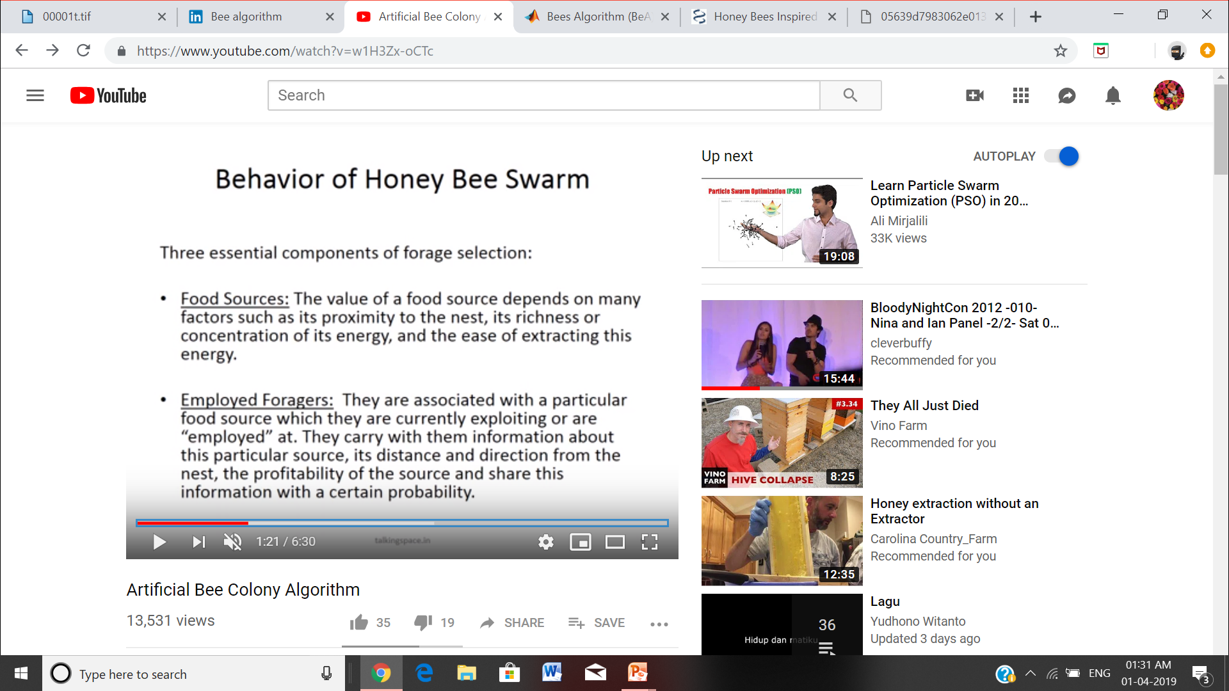

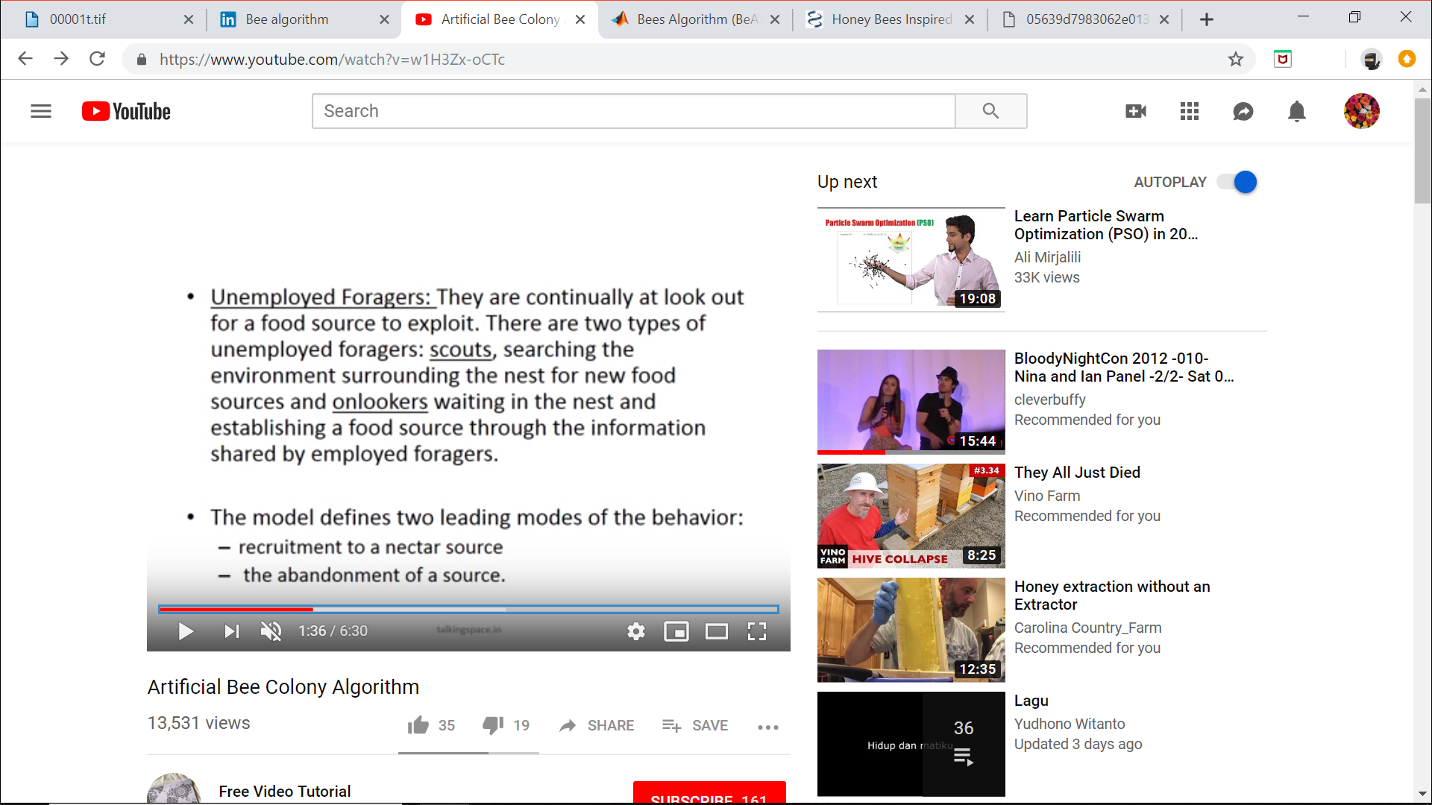

In the global search procedure, a number of bees are employed to explore at random the solution space. Each bee was associated with one solution. The solutions representing the fitness of individual bees were then ranked in descending order. The algorithm uses a population of agents (artificial bees) to sample the solution space.

